MPA 634  
Data Science for Managers  
Midterm I: Winter 2021

Exam parameters:

* Closed book
* No time limit
* Complete in one sitting
* Submit before starting the second part of the exam
* Due: 23 Feb before class

# I. Definitions and Concepts

1. Compare and contrast filter, mutate, and summarize. Your answer should include an explanation of how each one affects data frames or tibbles.
2. Identify and explain at least three different ways that you can use a violin plot to determine whether a distribution is positively or negatively skewed.
3. Carefully explain how the whiskers of a boxplot are constructed. How do whiskers help us identify outliers?
4. Define and explain each of the seven parts of the grammar of graphics by writing a script that illustrates the definition of each part.
5. Define distribution of a random variable and then compare the location, scale, symmetry, and outliers of city and highway mileage using the following information:

type_of_driving Mean Median Standard_Deviation Interquartile_Range

*<chr>* *<dbl>* *<dbl>* *<dbl>* *<dbl>*

1 cty 16.9 17 4.26 5

2 hwy 23.4 24 5.95 9

* 1. Location
  2. Scale
  3. Symmetry
  4. Outliers

# II. **Line by Line** Code Interpretation (Don’t interpret the first line)

Make sure that you explain in detail what is happening in each code step. Don’t just repeat the code. For example, explain what group_by accomplishes rather than just saying that group_by groups by the variable. Some students lose points when they don’t give sufficiently detailed explanations.

Code Chunk I

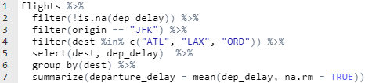

Code Chunk II

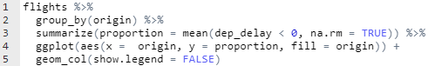

Code Chunk III

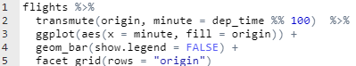

Code Chunk IV

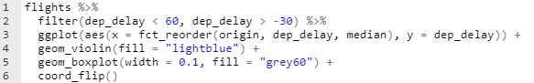

Code Chunk V

